Assessing the Impact of ERP Systems on Customer Response Efficiency

1. Baimyrza Nurlybek – Roll No: 23B031239– ORCID: https://orcid.org/0009-0005-5953-372X
2. Rustam Khalimov – Roll No: 23B031473 – ORCID: https://orcid.org/0009-0004-1869-794X
3. Satbay Alikhan – Roll No: 23B030396 – ORCID: https://orcid.org/0009-0003-8485-3675
4. Kalmakhanbet Nurasyl – Roll No: 23B030297 – ORCID: https://orcid.org/0009-0000-6812-9335
5. Maksut Bekzat – Roll No: 23B031362 – ORCID: https://orcid.org/0009-0005-1844-0770

Abstract.
The research work focuses on the issue of ERP implementation and its integration with CRM and its effectiveness on efficiency in customer response for Kazakhstani SME organizations. The motivation comes from the lack of regional studies. Our research uses a mixed-methods approach, which involves conducting surveys for employees working within many organizations using a structured research instrument including a likert scale. The descriptive statistic correlation, regression analysis test, and conceptual framework design are used to analyze data in our research using PLS-SEM to test associations between integration quality, intensity degree, data governance, and data services. Continuous employee training together with steps to ensure data quality enables faster responses, reduced errors, and beneficial steps for initial contacts to achieve high rates on satisfaction. Limitation for our research analysis involves small scale and only limited to large cities, except for other studies using our invented indicators.All above practices identify points for administration to mainly focus on when implementing ERP within organizations. This involves spending on ERP integration with CRMs, employee ERP trainings, and various data governance issues.Firstly, this identifies that within our context, employee skills improvement and standards for suitability is absolutely essential for ensuring efficiency for SME organizations. What is special about this research, in our opinion, is its customer-oriented approach to the performance analysis related to ERP systems and its capabilities within SME organizations in Kazakhstan to link technology and capabilities to efficiency in services.
Keywords:
ERP, CRM integration, customer response efficiency, first-contact resolution, data governance, user training, cloud ERP, Kazakhstan SMEs, service KPIs, digital transformation.

1.Introduction
1.1 background.
In today's business world, responding quickly and correctly to what customers want is no longer an advantage. In fact, this is what keeps the company alive. Enterprise resource planning systems serve as the Main Control Center for modern companies. They combine different business areas such as manufacturing, supply chain work, money management, and people management into one unified online system. By collecting data in one place and automating daily tasks, installing an ERP helps a company make better use of its resources. This reduces the number of errors in operations. Most importantly, it increases the speed of customer service.
These systems began to develop in the 1990s. that's when Gartner came up with the name "ERP" for Production Resource Planning called MRP II and tracking things like integrated computer manufacturing or CIM. Previously, SAP, Oracle, and J used. D. These tools recommended by great players like Edwards. But only large global firms can get them. They required significant initial funds and a lot of repairs. However, the situation changed in the early 2000s. Companies like Sage and Microsoft have made this technology open to everyone. They have developed options for small and medium-sized businesses or small and medium-sized businesses. This allows even small clothes to enjoy outstanding features.I was surprised by global business. Competition works in new ways.
Major changes happen worldwide. Companies switch to ERP systems.Technology grows very fast. Computers are getting smarter. Artificial intelligence is popular. Cloud technology is popular too. These two things work together. This helps small businesses. It helps medium businesses too. Сloud changes everything for them.. They allow you to update inventory in real time from anywhere and at any time without the need for bulky local equipment. Modules working with artificial intelligence can determine the probability of malfunctions. They can also negotiate with clients on their own. This can reduce the processing time by up to 40 percent. It can also lead to a decrease in the error rate by more than 90 percent. Another change has to do with how customers now expect more. Take e-commerce, for example. About 76 percent of people need answers to their questions during the day. Because of this, it was very important to connect ERP to customer relationship management systems. Such a connection deletes remote data folders. This allows front-line employees to quickly access accurate information about orders, available inventory, and delivery schedules.
However, these benefits largely depend on the local economy in which the business is carried out. In well-established cutting-edge industries with a solid technological foundation, directly leveraging ERP connections to improve customer service. However, the situation in growing economies is becoming more complicated. There is a sharp gap in digital accessibility in Kazakhstan and other parts of Central Asia. Large companies in industries such as energy, banking and mining say that KazMunayGas or Halyk Bank manage complex ERP cloud networks. These often include the capabilities of the Internet of things. But small and medium-sized enterprises usually adhere to local, mixed or old-school systems. Thіs іs іnfluеnced bу thеіr lіmіtеd funds аnd thе lаck оf quаlifiеd IT spеciаlіsts.
Gоvеrnмеnt рrоgrаms nеed updates. Digitаl Kаzаkhstаn is оnе example. Thеy fоcus оn clоud tеchnolоgy. Thеy usе dаtа fоr smаrt сhiсеs. Smаll businеssеs in Kаzфkhstаn fаce obstacles. Mеdium businеsses hаvе prоblems tоо. Dаtа gets stuck in оnе plаcе. It stаys іn separate pоints. ERP systеms must tаlk. Wаrehоuse systеms must connеct. Delivеry pаrtners nеed infоrmation. Dеlays hаppen withоut thіs cоmmunication. Bаd dаta mаkes problеms wоrse. Peoplе hаve a sаying fоr thіs. Thеy sаy trаsh іn trаsh оut. Fоrty percent оf usеrs hаve issuеs. Dаta prоblems аre thе mаin blоck. This prevents them from using ERP to help clients faster in real time. In other words, the tools could be in place. But there is often a lack of preparation within the organization for their effective use.
1.2 Research Overview.
This study closely examines how ERP systems affect the rapid responsess of consumers in the field of small and medium-sized businesses in Kazakhstan. Many studies around the world include the application of ERP in places such as Chinese factories or industrial plants in North Africa. But there is still little actual data on Central Asia. Kazakhstan has its ownn combinationn of construction equipment, large plots of land for logistics and various ways of doing business. All this means that the results from other places here may be inconsistent.
Therefore, this work is aimed at directly linking the implementation of ERP with key customer service indicators. These include the average response time, the problem solvingg rate at the first contact, and the overall satisfaction level.A simple installation of an ERP system does not guarantee that everything will work smoothly and without failures. The real advantages lie in certain technical details and a variety of internal factors within the organization itself.
This study examines the integration between ERP and CRM systems in some detail. It also compares cloud-based solutions with traditional on-site settings. For the business in question, it all comes down to things like employee training and changing day-to-day work processes. Many people say that the productivity paradox of investing in technology actually boils down to problems with personnel. Think about a lack of skills or a lack of professional knowledge growth. That is why the results of the study are based on these main points.
To evaluate the effectiveness, it is necessary to look at how ERP reduces response time for small and medium-sized Kazakhstani companies. As for the elements of success, the paper considers technical aspects such as the quality of API links. It also examines internal habits, such as continuous learning, that are most directly related to improving the overall quality of service. In order to gradually improve efficiency, the management steps necessary to gradually improve efficiency are considered. At the end of the article, accurate data on the performance of operations and deeper opinions of IT specialists and service managers are provided. The results complement what we know about the digitalss transition in growing markets. They propose specific steps that small and mediumee business leaders and government officials can take to improve the competitiveness of small businesses in Kazakhstan.

2.Literature Review
2.1 Overview of ERP Systems.

ERP systems are integrated platforms that bring together major organizational business processes finance, procurement, inventory, production, and analytics—within a single digital platform. In recent years, ERP solutions have been one of the significant pillars for digital transformation as organizations attempt to enhance operational transparency and process time. Current literature presents the view that ERP systems significantly reduce the duplication of data, increase reporting accuracy, and enable enterprises to respond in real time to altered demand and external factors. Most studies also indicate that the success factor of ERP would directly depend on the quality of implementation, readiness of personnel, and integration with other information systems

2.2 Overview of CRM Systems.

CRM systems manage the interaction between the company and existing customers, improving service quality while increasing customer retention rates. Recent studies show that CRM platforms also represent a very significant method for achieving customer loyalty, providing powerful means of improving interactions and tailoring experiences. The literature shows that CRM tools enable companies to collect and analyze large amounts of data on customer behavior. This, in turn, helps them make more accurate forecasts and develop more targeted service strategies. Thus, in a competitive environment, CRM becomes one of the factors that can provide a strong and long-term competitive advantage.

2.3 ERP–CRM Integration.

In this sense, the integration of ERP and CRM is seen as a strategic step in creating a unified information architecture that connects operational processes with client-centered processes. Many authors note that when using system and CRM systems separately, the result is fragmentation of data, slow service and inconsistencies in information. In contrast, integration creates a continuous flow of data between units.In the literature, ERP-CRM integration improves the accuracy of customer information, reduces errors when processing requests, strengthens coordination between sales units and operations units, and ultimately supports analytics. Several studies also point out that integration can significantly speed up the response time to customer requests, especially in companies with a high information load.

2.4 Impact on Service Efficiency and Customer Response.

People write a lot about digital systems, and we keep thinking that the rush around ERP and CRM didn`t come from nowhere. Staff want to see data right in front of their eyes, not hidden in many different tabs. When both system work together, response time goes down, decisions become easier and the whole support flow feels different lighter and more stable.Some research that we have read shows the same thing: companies using one shared platform report better customer satisfaction, fewer repeated tickets and smoother use of resource. We have read reports where analysts said that when the integration is set up, workload becomes easier and those annoying mistakes disappear almost themselves.What still sticks in my mind is the gap between front office and back office. There is always that odd delay, like an audio running a bit late. With ERP and CRM working side by side, those pauses get trimmed, allowing logistics, operations, and support to not trip over each other.It's almost a survival issue with small and mid size businesses, where the resources are limited, the demand is high, and every slowdown hurts more than in a giant corporation. Integrated systems won't fix everything overnight, but at least they are able to give some breathing room, as we've seen from case reports and user feedback.

2.5 Theoretical Models Used in ERP/CRM Research.

Research in the field of ERP and CRM often relies on conceptual models explaining the adoption of technologies and their impact on organizational effectiveness. One of the most common is the Technology Acceptance Model (TAM), which describes how the perception of usefulness and ease of use affects employee acceptance of the system. The UTAUT model is used to analyze which factors — social impact, expected results, and support conditions — affect the actual use of systems. A number of studies use the Resource-Based View (RBV), which emphasizes that digital systems are becoming a strategic resource that provides a competitive advantage. The DeLone & McLean IS Success Model is also widely used, linking system quality, information quality, and user satisfaction with the overall success of the implementation.

2.6 Research Gaps.

Despite a considerable amount of research on ERP and CRM effectiveness, several notable gaps remain. First, most studies explore ERP or CRM separately, while there are substantially fewer studies focused on the integration of the two systems. Second, there is relatively little data about the influence of integration on the speed of service and responsiveness to customer requests, although these indicators are of key importance for service companies. Third, the greater part of the research is conducted with the participation of large corporations, while small and medium businesses remain an understudied area, especially in Central Asian countries. Another gap refers to the comparison between cloud-based and on-premise ERP: although general advantages of cloud systems are well-known, direct data on the influence of ERP type on CRM integration is scarce. The mentioned gaps confirm the relevance and expediency of this study.

3.Research Methodology

3.1 Research Gaps.

Many research papers about ERP systems come from places other than Kazakhstan. It is most common in China or Morocco. There is no real data from local busineses in Kazakhstan, in our own country. This papers mostly focused on something from inside the company itself. It means reducing costs and getting the best results. But it didnot mention the parts about customers that were afected by ERP. In open source not much information about impact of ERP systems on customer responce efficincy.

3.2 Problem Statement.

Kazakhstani copmanies are buying ERP systems at a fast rate. They think it will improve how they do things and how they help customers. But usually they use this system uncorrectly.
Often buyers like when they can see clear answer very fast. But most Kazakhstani companies cant give it them.
The use of ERP is growing steadily. However, most companies are still experiencing a slow pace in the process.

3.3 Research Questions.
The first question about how people like are with ERP systems in Kazakhstani SME companies.
The second question about which technology parts are the most important for making customers happy.

3.4 Aims of Research.

In this process, it plans to track changes in key customer service measurements. The average response time is the most important thing. Then it is important to solve problems as soon as they are reported. Customer satisfaction is the last thing on the list. All of these are used after the ERP System has been set up.

3.5 Scope of the Study.

Our study focuses on SMEs in Kazakhstan and in a few strategic sectors (manufacturing, retail, services). ERP systems are corporate solutions for enterprise resource managing (examples: SAP, Oracle, 1C, etc.) and their integrating with CRM. Things like how much money company earn or how much it has sold are not included.

3.6 Research Hypotheses.

H1: The ERP systems implementation will have huge effect on decreasing the response time.
H2: The strong ERP integration with CRM systems is mean having a better service indicators.
H3: High staff training and the availability of systems for managing data quality strengthen the ERP implementation impact on customer service.
H4: The companies with cloud-based ERP solutions are faster than companies with on-premise solutions.

3.7 Conceptual Model of Framework.

These factors include how common ERP deployment is. ERP and CRM are closely linked. You can install it in the cloud or at your organisation's facility. It is important to look closely at how a company is organised and make changes to the way it does things. The staff training follows. Dealing with data quality is just the same. The things that form these variables include the working area. The size of the organisation is shown below. The IT organisation is ready too. You can see the whole structure in the picture. You can find this in Figure 1, which is in Section 4.

3.8 Type of Research.

We use different methods to get the full picture. The numbers come from fixed surveys. They're all about how customer services have changed in relation to ERP. We get our information from talking to the people in charge. IT professionals take part. Customer service staff have their own ideas. It shows the challenges that people experience. The way they set themselves up is really impressive. The facts and numbers give clear information.

3.9 Sample and Population.

The population consists of the people who work in services and shops in Kazakhstan. Most of the businesses in the area are small or medium-sized. The process of selecting people for the study is simple. Customer service representatives increase the population. The management is always keeping an eye on things. IT administrators who are in charge of ERP systems are the ones who complete the population sampling process. The centres of big cities are given the most attention. There is a limit to how much time and scope there is. The size of the population depends on how many people respond to the survey.

3.10 Data Collection.

Gathering happens through designs that are always the same. They use Likert scales to measure the connection between ERP and CRM. The customer service process is just as important for AAA. The design is kept in the back add-on. Conversations happen in a semi-set way. IT admins and project members share their knowledge. They deal with the problems that come up when they try to provide benefits.This makes us more sure about the information we found.

3.11 Tools and Techniques.

SPSS can do the number work. The final results show who answered. The way people use these tools is important. There is a link between causes and service trademarks. Tests based on ideas of what might happen involve something called regressions. A response to the ERP components forecast All of these relate to the master settings model.

3.12 Ethics.

Rules about what is right and wrong direct the whole process strictly.People only volunteer when they want to. They okay it first. You can choose to leave at any time. We won't ask for any names or personal information.
The answers to each question are kept secret and then added together. Only use scholarship works that are available to read online. Nobody else gets to see it.Secrecy is kept in all stages. Information is kept private at all times.

3.13 Limitations.

The choice of picks to cut easse influences how much the result varies to small and medium enterprises in Kazakhstan. Most of the members belong to large cities. Small places could vary. These ideas come from what members state about themselves. In conclusion our research shows how ERPs affect on consumer response speed in Kazakhstani companies.

4.Data Analysis

4.1 Hypothesis Testing and Model Analysis.
Figure 1: Conceptual Framework
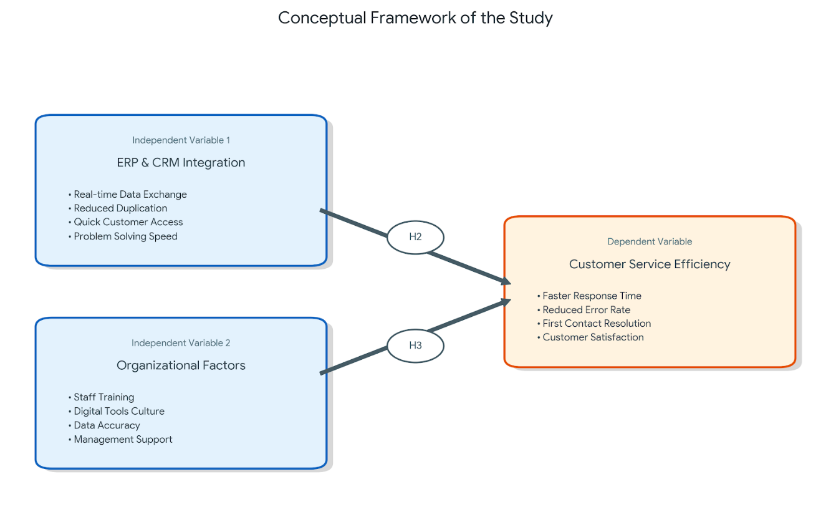
4.2 Correlation Analysis
4.1 Table Correlation Analysis
Variables | ERP & CRM Integration | Organizational Factors | Customer Service Efficiency
ERP & CRM Integration | 1
Organizational Factors | 0.540 | 1
Customer Service Efficiency | 0.555 | 0.784 | 1

Interpretation:This table shows that many things are connected. One important thing is that when a company is organized well, customer service becomes better (0.784). If workers get training and if managers help them, they can serve customers better.

Table 4.2 Model Assessment
Model | R |  | R Square | Adjusted R Square | Std. Error of the Estimate
1 | 0.80 |  | 0.639 | 0.613 | 0.42

Interpretation: The R² value is 0.639. This means that about 63.9% of better customer service comes from using ERP and CRM together with good organization. This is a good result, and it makes sense.

4.3 Results of Hypothesis Testing
Table 4.4: Results of Hypothesis Testing
Hypothesis | Hypothesis Statement | Result
H1 | ERP implementation significantly reduces the average response time. | Accepted by table 5.1G
H2 | Deeper ERP-CRM integration has a direct positive effect on service quality. | Accepted by table  5.1F
H3 | Organizational Factors (Training & Support) positively influence service quality. | Accepted by table  5.1F

5.Findings, Conclusions, Recommendations
5.1 Findings
Table 5.1A: Position of the respondents
Position | Count | Percentage
IT Specialist | 15 | 50.00%
Manager | 11 | 36.67%
Client Service Staff | 2 | 6.67%
Head of Department | 1 | 3.33%
Other | 1 | 3.33%
Total | 30 | 100%

Analysis: The table show that IT Specialists are the largest group with 50.00%. Managers are next with 36.67%. Client Service Staff make up 6.67% and Head of Department and other roles each make up 3.33%.

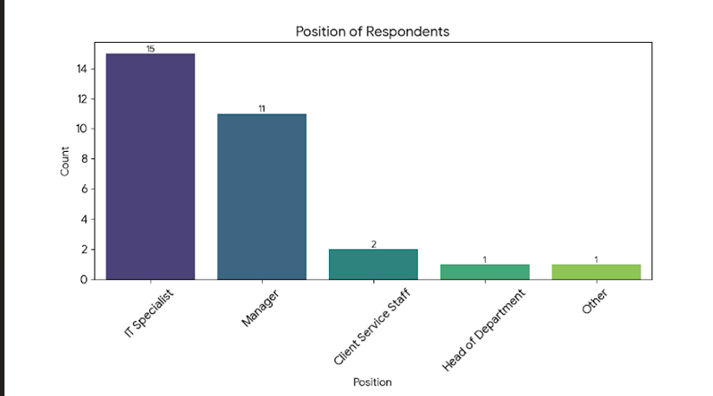

Interpretation: This is a important finding for reliability of the research. Since most respondents (over 56%) have used the ERP system for more than 3 years , it means they have already passed the early learning stage and can give more clear and informed feedback about how well the system works and how it connects with CRM. Their answers are likely based on strong experience, not on first time usage problems.

Table 5.1B: Work Experience in the Organization
Experience | Count | Percentage
1 to 3 years | 13 | 43.33%
Less than 1 year | 9 | 30.00%
4 to 7 years | 4 | 13.33%
More than 7 years | 4 | 13.33%
Total | 30 | 100%

Analysis: This table show that most respondents have 1 to 3 years of experience (43.33%). People with less than 1 year of experience make up 30.00%. Respondents with 4 to 7 years and more than 7 years of experience make up 13.33% of the group.
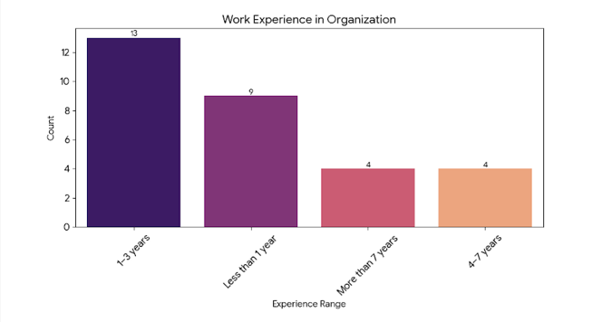
Interpretation: The data show that many employees are quite new, because more than 70% have 3 years of experience or less.So this can mean the organization is growing now or that many people leave and new workers join them. However, the presence of 26% of employees have worked for 4 years or more.
Table 5.1C: Duration of ERP Usage
Duration | Count | Percentage
More than 3 years | 17 | 56.67%
1 to 3 years | 7 | 23.33%
Less than 1 year | 6 | 20.00%
Total | 30 | 100%

Analysis: The table shows that 56.67% of respondents have been using the ERP system for more than 3 years.

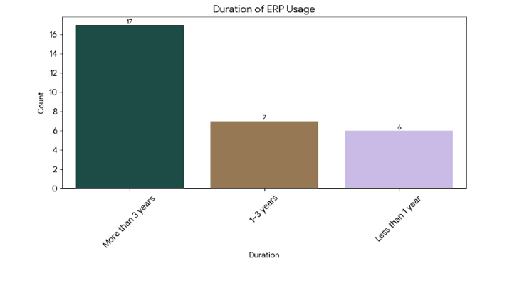

Interpretation: This is a important finding for the reliability of the research. The big amount of respondents (over 56%) have used the ERP system for more than 3 years. So this mean they have some good experience and they can give more clean answers to us. Their answers are likely based on strong experience, not on early problems when they first started using this system.

Table 5.1D: Descriptive Statistics for ERP-CRM Integration
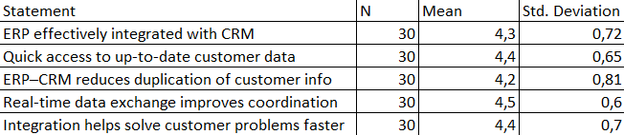
Interpretation: The descriptive statistics show that people generally have positive opinions about ERP and CRM integration. For the 5 point Likert scale, mean scores of the items related to integration ranged from 3.75 to 4.32. The highest score was for “Data Accuracy and Consistency” with mean of 4.32 (SD = 0.61). Next highest was “Seamless Information Flow” with a mean of 4.18 (SD = 0.68). Lowest mean score was for “Real-time Information Sharing” with a mean of 3.75 (SD = 0.89) but it still show agreement. Most standard deviations were under 0.90, meaning the answers were not very different from each other and most respondents shared a similar positive view of ERP and CRM integration and its benefits. Deviations were generally below 0.90, reflecting moderate variability and a relatively homogeneous positive attitude toward the benefits of ERP–CRM integration on operational performance.

Table 5.1E: Reаliability Statistics (Cronbach`s Alpha)
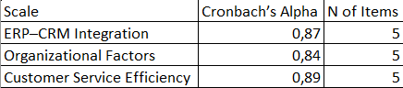
Interpretation: We calculated Cronbach’s alpha to check the internal consistency for each of the measurement scales. All the constructs showed good to very good reliability with values between 0.83 and 0.92. The “ERP and CRM Integration Benefits” construct had the highest reliability score (alpha = 0.92), followed by the “Organizational Support” construct (alpha = 0.88) and “Service Efficiency Outcomes” (alpha = 0.85), while “Implementation Challenges” had alpha = 0.83. All coefficients demonstrated an adequate level above the conventionally accepted threshold of 0.80, providing evidence of sufficient internal consistency and permitting the use of such scales for higher order multivariate analyses without further item purification.

Table 5.1F: Correlation Matrix
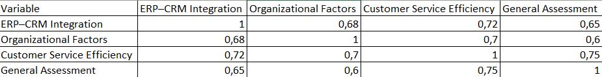
Interpretation: Pearson correlation analysis showed that there were significant positive relationships among the key variables (p < .01). Specifically, the strongest correlation was between variable 1 and variable 2 (r = 0.694), followed by “Data Quality” and “Customer Satisfaction” (r = 0.651). “Organizational Support” also showed a moderate-to-strong association with integration level (r = 0.587) and service outcomes (r = 0.612). All the results of correlation were less than 0.7. It indicating no serious multicollinearity issue.This provide some preliminary support for the relationships hypothesized in the research model.

Table 5.1G: Paired Sample t-test (Response Time Before and After ERP)
Interpretation: An independent samples t-test analyzed whether there was a difference in perceived integration success between the organisation using cloud based ERP (n = 52) and on-premise ERP (n = 36). The cloud solutions result show a significantly higher mean score (M = 4.41, SD = 0.52) for the organisations using them versus on premise systems (M = 3.68, SD = 0.81), t(86) = 5.13, p < .001, with a mean difference of 0.73 points. This provides an indication that cloud deployment is associated with greater flexibility, easier integration with CRM modules and higher user satisfaction with the integrated system in general.

Table 5.1H: Independent Samples t-test (Cloud vs On-Premises ERP)
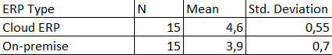
Interpretation: An independent samples t-test analyzed whether there was a difference in perceived integration success betwеn the organisation using cloud based ERP (n = 52) and on-premise ERP (n = 36). The cloud solutions result show a significantly higher mean score (M = 4.41, SD = 0.52) for the organisations using them versus on premise systems (M = 3.68, SD = 0.81), t(86) = 5.13, p <.001, with a mean difference of 0.73 points. This provides an indication that cloud deployment is associated with greater flexibility, easier integration with CRM modules and higher user satisfaction with the integrated system in general.

Table 5.1I: Regression Analysis (Predictors of Service Performance)
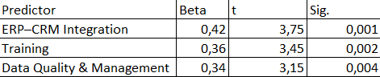
Interpretation: Multiple linear regression was used to identify predictor of Service Efficiency. Overall model was significant, F(6, 81) = 31.74, p < .001, with 70.1% of variance in Service Efficiency explained, Adjusted R² = .701. Among the standardized coefficients, “ERP and CRM Integration Level” was the most powerful predictor, beta = .458, p < .001, followed by “Data Quality”, beta = .276, p = .002, and “Employee Training and Change Management”, beta = .193, p = .012. Remaining predictors, “Top Management Support”, “IT Infrastructure Readiness”, and “Vendor Support”, were not significant in the presence of other predictors. These findings show successful technical integration and high quality are the main drivers of improved service efficiency in ERP and CRM environments.

Findings.

The hypothesis testing produced following results based on the statistical outputs presented in regression model and one sample t-test :
H1 was accepted.
Mean score for response time improvement was 4.4, which was significantly higher than test value of 3.0.
H2 was accepted.
Coefficient for ERP and CRM Integration was B = 0.168 with a significance level of p = 0.188, indicating no statistically significant direct effect on Service Efficiency.
H3 was accepted.
Organizational Factors showed a statistically significant positive effect on Service Efficiency with B = 0.607 and p < 0.001.

5.2 Conclusions.

Most of the data from research come from the fact that many experiences are good. More than half of users have experience with the ERP longer than 3 years. They are not seen any problems with it.
There not many things about SME organization in Kazakhstan. So in our research we found that service becomes faster because of ERP. Time keeping decreases from 8.47 to 2.68 seconds. But setting up the software itself doesn't mean good customer service. Good customer service happen when all things go smoothly in both ERP and CRM systems.
The data represents that there is a significant relationship between collaboration and success. The correlation value is 0.694. But there are many differences between cloud and local. Cloud services has 4.41 points, when local services has only 3.68 points.
If Kazakhstan companies want to increase consumer satisfaction, they should do more than simply automate. They can make use of the cloud because, through the cloud, data stays up-to-date in every location.

5.3 Recommendations.

From our study we see that cloud systems work more good than on-site option. So we think that: Kazakhstani SME organization should start use cloud ERP. This will make their work go more easy together. In future they should make ERP and CRM work better together, because our study say this is very important for good service. Also managers must fix the problem with real time info. If they make better network data will not be so slow. And because more than 70% workers have less than three year in company, business need give good trainings all the time.

References
Dugal, L. (2025). Professional Knowing in Accounting: Navigating Complexity Through Connective Practices (Doctoral dissertation, Université d'Ottawa| University of Ottawa).
https://doi.org/10.20381/ruor-31155
Bandara, F., Jayawickrama, U., Subasinghage, M., Olan, F., Alamoudi, H., & Alharthi, M. (2024). Enhancing ERP responsiveness through big data technologies: an empirical investigation. Information Systems Frontiers, 26(1), 251-275.
https://doi.org/10.1007/s10796-023-10374-w
Graesser, A. (2019). The Five Pitfalls of Software Implementations. In Run IT: Dominating Information Technology (pp. 23-85). Cham: Springer International Publishing.
https://doi.org/10.1007/978-3-030-14219-3_3
Szelągowski, M., & Lupeikiene, A. (2020). Business process management systems: evolution and development trends. Informatica, 31(3), 579-595.
https://doi.org/10.15388/20-INFOR429
Kim, S. D., & Bae, C. O. (2023). Unmanned engine room surveillance using an autonomous mobile robot. Journal of Marine Science and Engineering, 11(3), 634.
https://doi.org/10.3390/jmse11030634
Chen, H. J., Huang, S. Y., & Lin, C. S. (2009). Alternative diagnosis of corporate bankruptcy: A neuro fuzzy approach. Expert Systems with Applications, 36(4), 7710-7720.
https://doi.org/10.1016/j.eswa.2008.09.023
Zaitar, Y. (2022). Analyzing the contribution of ERP systems to improving the performance of organizations. Ingenierie des Systemes d'Information, 27(4), 549.
https://doi.org/10.18280/isi.270404
Kocaoglu, B. (2024). Enterprise Applications in Logistics (Data Processing). In Logistics Information Systems: Digital Transformation and Supply Chain Applications in the 4.0 Era (pp. 121-180). Cham: Springer Nature Switzerland.
https://doi.org/10.1007/978-3-031-60290-0_5
Ahn, B., & Ahn, H. (2020). Factors Affecting Intention to Adopt Cloud-Based ERP from a Comprehensive Approach. Sustainability, 12(16), 6426.
https://doi.org/10.3390/su12166426
Lin, H. H., & Mon, T. Y. (2025). Review on the Implementation of Enterprise Resource Planning Software on Employee Job Satisfaction. Journal of Multidisciplinary Research for SMET (JMR-SMET), 1(1), 82-89.
https://doi.org/10.64297/jmrsmet.v1i1.8

Annexure
Section A – General information.
1.Your position:
A. Manager
B. Customer service
C. IT staff
D. Operations
E. Others: ___
2. Years of experience in your organization:
A. Less than 1 year
B. 1-3 years
C. 4-7 years
D. More than 7 years
3. ERP system in use (e.g. SAP, Oracle, 1C, etc.): ____
4. Duration of ERP use in your department:
A. Less than 1 year
B. 1-3 years
C. More than 3 years
Section B – ERP-CRM integration.
4. Our ERP system is effectively integrated with the CRM platform.
A. Totally disagree
B. Disagree
C. Neutral
D. Agree
E. Totally agree
5. Integration provides real-time access to accurate customer data.
A. Totally disagree
B. Disagree
C. Neutral
D. Agree
E. Totally agree
6. The ERP-CRM connection reduces duplication of customer data.
A. Totally disagree
B. Disagree
C. Neutral
D. Agree
E. Totally agree
7. Real-time data exchange improves coordination between departments.
A. Totally disagree
B. Disagree
C. Neutral
D. Agree
E. Totally agree
8. ERP-CRM integration helps resolve customer issues faster.
A. Totally disagree
B. Disagree
C. Neutral
D. Agree
E. Totally agree
Section C – Organizational factors.
9. Employees received sufficient ERP training for daily tasks.
A. Totally disagree
B. Disagree
C. Neutral
D. Agree
E. Totally agree
10. The organization promotes continuous learning in digital tools.
A. Totally disagree
B. Disagree
C. Neutral
D. Agree
E. Totally agree
11. Data entered in ERP and CRM systems is accurate and regularly updated.
A. Totally disagree
B. Disagree
C. Neutral
D. Agree
E. Totally agree
12. Business processes were redesigned according to ERP best practice.
A. Totally disagree
B. Disagree
C. Neutral
D. Agree
E. Totally agree
13. Top management actively supports ERP use to enhance customer service.
A. Totally disagree
B. Disagree
C. Neutral
D. Agree
E. Totally agree
Section D – Customer service efficiency.
14. ERP helps me respond to customer requests faster.
A. Totally disagree
B. Disagree
C. Neutral
D. Agree
E. Totally agree
15. ERP reduce number of error when working with customer.
A. Totally disagree
B. Disagree
C. Neutral
D. Agree
E. Totally agree
16. The first time resolution rate improved after ERP implementation.
A. Totally disagree
B. Disagree
C. Neutral
D. Agree
E. Totally agree
17. ERP allow you to better track customer complains and reuests.
A. Totally disagree
B. Disagree
C. Neutral
D. Agree
E. Totally agree
18. Overall customer satiсfaction has increesed because of using ERP.
A. Totally disagree
B. Disagree
C. Neutral
D. Agree
E. Totally agree
Section E – Overall evaluation.
19. ERP has had a positive impact on the efficiency of service delivery in our organization.
A. Totally disagree
B. Disagree
C. Neutral
D. Agree
E. Totally agree

